Homeownership Pre-Application Form
A world where everyone has a decent place to live.

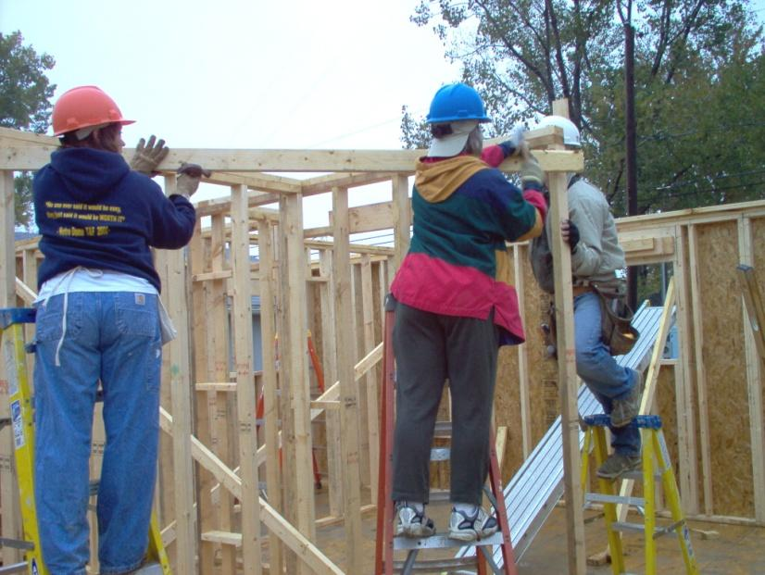

Dear Applicant,

Habitat for Humanity is a non-profit organization building decent, affordable homes for lower-income families in Wood County. Our Homeowner Selection Committee will review the information you provide upon a completed application. Following an initial review, we will contact you regarding next steps towards an application for a home. If you do not meet these general guidelines, we will notify you by letter. Please be patient, this review process can take up to 30 days.

Thank you,
Homeowner Selection Committee

You must submit the following documents with this pre-application:
- Last 2 consecutive years of most recent federal tax returns filed (first two pages only, signed by applicant(s))
- 8 weeks of pay stubs for each applicant
- Documentation of all other household income
(e.g. social security, disability, food stamps and child support)
WE CANNOT REVIEW YOUR APPLICATION WITHOUT THESE DOCUMENTS

When you have completed this application please return it to:
Habitat for Humanity of Wood County
P.O. Box 235
Bowling Green, OH 43402
(419) 481-8100

Before you apply!
- All liens and judgments must have been cleared prior to application
- Please call us if you are in need of a financial consultation on your situation
- All adult members of your household are subject to a Criminal Background check and sex offender registry review

Please describe your situation in the following criteria:

Housing Need:
The housing I live in is:
Overcrowded ____ Poorly maintained (substandard) ____
In a dangerous neighborhood ____ A temporary housing situation ____
Other________________________

Ability to Pay:
Habitat homeowners purchase their Habitat home and are required to pay their monthly mortgage payment without incurring undo financial hardship. Your credit history will be considered in this regard.

- What is your estimated monthly household income? __________________
(Monthly income includes jobs, social security, disability, food stamps, and child support, if reliable).
- Bankruptcy status: Have you had a bankruptcy? YES NO (please circle one).
If yes, when did you file for bankruptcy? __________
What date was it discharged? _________

Willingness to Partner:
The homeownership program requires that you partner with Habitat by completing 200 “Sweat Equity” hours (volunteer hours) per applicant. Sweat equity is completed by attending mandatory monthly Homeowner workshops, completing Financial Peace University, volunteering with us in the office and working on your home and those of other Habitat families.

Are you willing to do this? YES NO (please circle one).

- Have you ever been charged with or convicted of a crime other than a minor vehicle violation? YES NO (please circle one).

We do our best to match the area you wish to live in with what we have available, but we cannot guarantee a match. Please indicate your top three areas in Wood County in which you would be willing to purchase a Habitat home.
- _____________________________________
- _____________________________________
- _____________________________________

Highest Level of Education: ________________ ________________
Applicant Co-Applicant

Are you currently enlisted, a veteran or a spouse of a veteran or military personnel?

Please provide the following information and sign the authorization on the back:

Applicant Name: (Please Print)

_______________________________

Marital Status: (Please circle one)

Unmarried Married Separated

Contact Information:
Home: _____________________________
Work: _____________________________
Cell: _____________________________
Email:
_____________________________
Co-Applicant Name: (Please Print)

_______________________________

Marital Status: (Please circle one)

Unmarried Married Separated

Contact Information:
Home: _____________________________
Work: _____________________________
Cell: _____________________________
Email:
_____________________________
Address: (Print) Address: (Print)
_____________________________ _____________________________
_____________________________ _____________________________
_____________________________ _____________________________
Is Applicant a U.S. citizen or permanent resident? Yes No (circle one)
Is Co-applicant a U.S. citizen or permanent resident? Yes No (circle one)
If “no”, please explain: _____________________________________________________

Please provide the following information for all the people who will be living in the home including you and co-applicant (if applicable).

Name Date of Birth Relationship
__________________________ _________________ _________________
__________________________ _________________ _________________
__________________________ _________________ _________________
__________________________ _________________ _________________
__________________________ _________________ _________________
__________________________ _________________ _________________
__________________________ _________________ _________________
__________________________ _________________ _________________

Please list all sources of income received on a monthly basis and send in required proof of income. We cannot review your application without these documents.
Monthly income includes jobs, social security, disability, food stamps, and child support (if reliable).

Source of Income Gross Amount (before taxes)
________________________________ ___________________________
________________________________ ___________________________
CREDIT REPORT AND BACKGROUND VERIFICATION AUTHORIZATION FORM
I hereby authorize and instruct Habitat for Humanity of Wood County Ohio (“HFHWC”) to obtain and review my credit report and a background verification. My credit report and background verification will be obtained from consumer reporting agencies chosen by HFHWC. Note: HFHWC does not look at or consider an applicant’s credit score.
I understand and agree that HFHWC intends to use the credit report for the purpose of evaluating my financial readiness to purchase a home. I further understand and agree that HFHWC intends to use the background verification for the purpose of evaluating my character and willingness to partner with HFHWC.
I authorize ___ I do not authorize __
I understand that I may revoke my consent to these disclosures by notifying HFHWC in writing. You have the right to request that we make complete and accurate disclosure of the nature and scope of the information requested. Such disclosure will be made to you within five (5) days of the date on which we receive a written request from you or within five (5) days of the time the report was first requested, whichever is later. The Fair Credit Reporting Act gives you specific rights in dealing with consumer reporting agencies.
I affirm that the information that I have provided is true and accurate to the best of my knowledge. I understand that providing false information may cause my disqualification for the purchase of a HFHWC home.

Applicant’s Name (Print) Co-Applicant’s Name (Print)

Applicant’s Signature Co-Applicant’s Signature

Applicant’s Social Security Number Co-Applicant’s Social Security Number

Date: Date:

For Office Use Only – Do Not Write In This Space

Date received: ________________ Date of Application Meeting: ______________

Date of Adverse Action/Missing Documentation Letter: ____________

The Federal Equal Credit Opportunity Act prohibits creditors from discriminating against credit applicants on the basis of race, color, religion, national origin, sex, marital status, age (providing the applicant has the capacity to enter into a binding contract); because the applicant’s income derives from any public assistance program; or because the applicant has in good faith exercised any right under the Consumer Credit Protection Act. The federal agency that administers compliance with this law: Federal Trade Commission, Equal Credit Opportunity, Washington, D.C. 20580

